NAAN MUDHALVAN ARTS INTERNSHIP PROGRAM 2026
Frontend Web Development using React
Project Submission

STUDENT NAME : JAYASRI S
YEAR : III-YEAR
COLLEGE CODE : BRUAU
COLLEGE NAME : GOVERNMENT ARTS AND SCIENCE COLLEGE AVINASHI (CO-EDUCATION)
DEPARTMENT : B.Sc (COMPUTER SCIENCE)
SEMESTER : IV SEMESTER
ROLL NO : 2422k1176
NMID : cd4ee5519e7c3d6b581472720ba5e9dd
DATE : 18/06/2026
TITLE: DAILY EXPENSE ANALYTICS DASHBOARD
GITHUB LINK : https://github.com/jayasricheeta572007-bit

- ABSTRACT
This project focuses on the development of a Daily Expense Analytics Dashboard using React.js. The application helps users efficiently manage their personal finances by recording daily income and expenses. Users can categorize transactions, track spending patterns, and monitor their available balance in real time. The dashboard provides a simple and interactive interface along with basic analytics that summarize expenses by category. This system improves financial awareness and helps users make better budgeting decisions.

- PROBLEM STATEMENT
Many individuals find it difficult to track their daily income and expenses manually. Without proper monitoring, it becomes challenging to understand spending habits, manage budgets, and maintain financial stability. There is a need for a simple and user-friendly dashboard that allows users to record transactions, categorize expenses, calculate the remaining balance, and view basic spending analytics in one place.

3.OBJECTIVES
❖ To develop a simple and responsive Daily Expense Analytics Dashboard using React.js.
❖ To enable users to add and manage income and expense records efficiently.
❖ To provide category-wise tracking of expenses for better financial awareness.
❖ To calculate and display the total balance automatically based on transactions.
❖ To generate basic analytics and summaries that help users understand their spending patterns.
4.PROJECT SCOPE
In-Scope Features:
❖ Add and manage income and expense transactions.
❖ Categorize expenses such as Food, Travel, Shopping, Bills, and Others.
❖ Display total income, total expenses, and available balance.
❖ Show category-wise expense summaries.
❖ Provide a responsive and user-friendly dashboard interface.
Out-of-Scope / Future Enhancements:
❖ Database integration for permanent data storage.
❖ User authentication and account management.
❖ Advanced analytics and graphical reports.
❖ Export reports to PDF or Excel.

5. TECHNOLOGIES USED
❖ Frontend Framework: React.js
❖ Programming Language: JavaScript (ES6)
❖ Styling: CSS3
❖ Development Environment: Node.js and npm
❖ Code Editor: Visual Studio Code

6. APPLICATION FLOW
The user opens the application and views the dashboard.
❖ The user enters income or expense details along with category information.
❖ The application stores the transaction and updates the dashboard instantly.
❖ Total income, expenses, and balance are calculated automatically.
❖ Category-wise summaries are displayed for expense analysis.
❖ Users can review and manage their financial records through the dashboard.

7. KEY REACT CONCEPTS USED
❖ useState Hook: Used to manage transaction records, income, expenses, and balance.
❖ Event Handling: Captures user inputs and transaction submissions.
❖ Conditional Rendering: Displays messages when no transactions are available.
❖ List Rendering: Uses map() function to display transaction history dynamically.
❖ Component-Based Architecture: Organizes the dashboard into reusable UI components.

8. CHALLENGES FACED

Challenge:
Managing real-time balance calculations whenever a new transaction is added or removed.
Resolution:
Implemented state management using React Hooks to automatically update income, expenses, and balance whenever transaction data changes.

9. EXPECTED OUTPUT
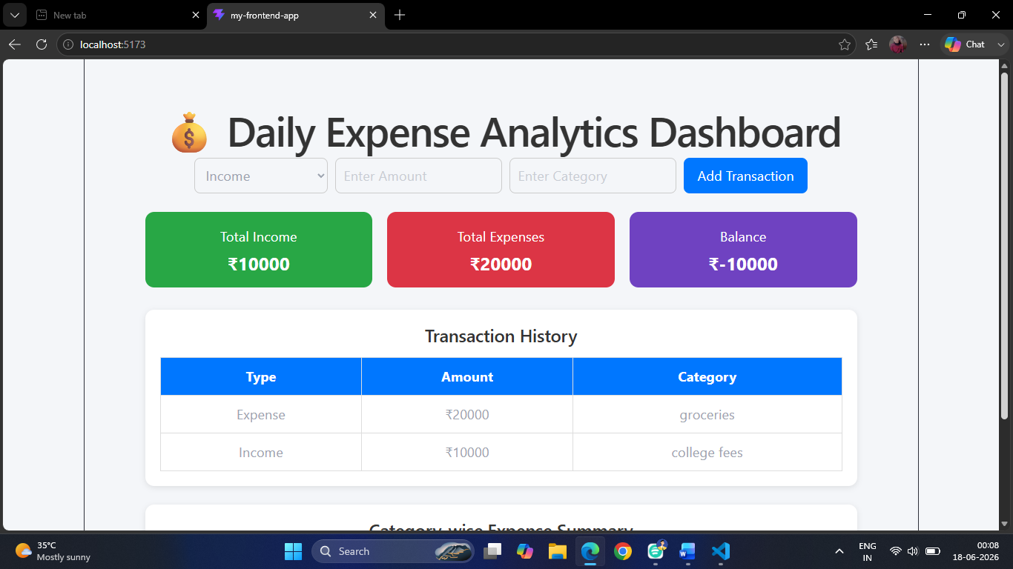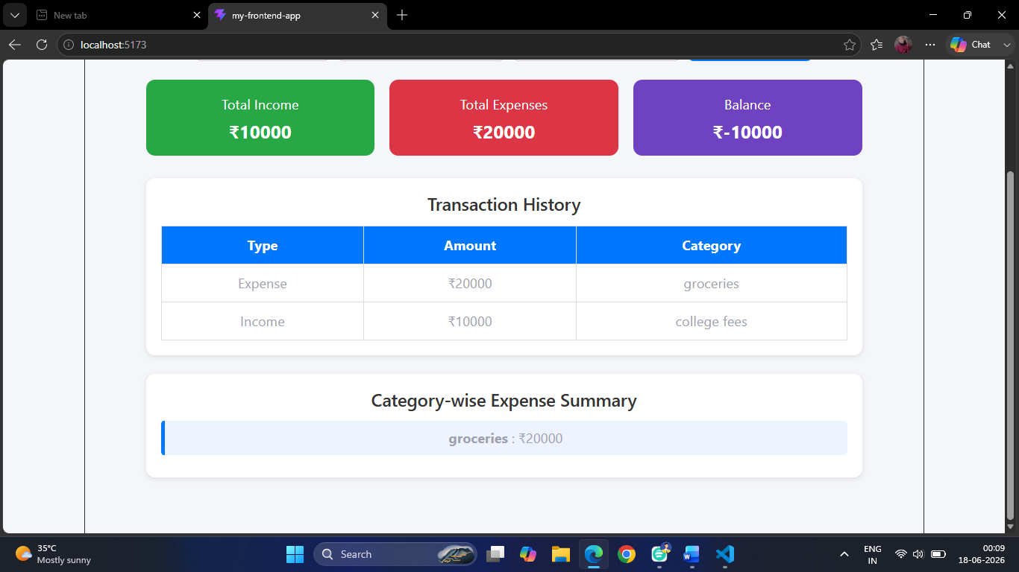
❖ Dashboard displaying total income, total expenses, and remaining balance.
❖ Transaction list showing all income and expense records.
❖ Category-wise expense summary.
❖ Responsive and user-friendly interface for daily expense tracking.

10. LEARNING OUTCOMES
❖ Learned React.js fundamentals and component-based development.
❖ Gained experience in state management using React Hooks.
❖ Improved skills in handling user inputs and dynamic data updates.
❖ Understood financial data tracking and analytics implementation.
❖ Enhanced frontend development and UI design skills.

11. CONCLUSION
The Daily Expense Analytics Dashboard successfully provides a simple and effective solution for managing personal finances. By enabling users to record income and expenses, monitor balances, and analyze spending patterns, the application promotes better financial planning and budgeting. This project demonstrates the practical use of React.js in building interactive and responsive web applications.

